Homework 01

EIGEN ANALYSIS OF FLUTTER

A. Aeroelastic Model 3
B. Ground Vibration Test (GVT) Analysis 10
C. Flutter Analysis 13
D. Damped GVT and Flutter 23
E. Extra Credit Challenge Problems 30
List of MATLAB codes Error! Bookmark not defined.

Consider an airfoil in wind tunnel testing with airspeed U (Figure 1). The airfoil is supported by springs at P. The center of mass is at C. The distance from P to C is the static offset x_{CP}. The aerodynamic lift L acts at Q. The distance from P to Q is the aerodynamic offset x_{QP}. The airfoil undergoes oscillatory motion with plunge displacement h(t) and pitch displacement θ(t). The positive plunge direction is downward. The positive pitch direction is “nose up” (clockwise).
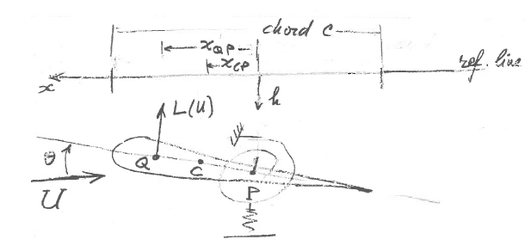
Figure 1: Airfoil in wind tunnel testing
Input data
Air density: ρ=1.225 kg/m³
Chord: c=0.4 m
Mass, m=2.8 kg
Mass moment of inertia, I₀=0.05 kg.m²
Plunge frequency, f_{h}=1.6 Hz
Pitch frequency, f_{θ}=4.8 Hz
Static offset, x_{CP=} –10% of c
Aerodynamic offset, x_{QP}= 30% of c

NOTES:
- Always display input data!
- Show work and relevant comments
- Partial credit might be given based on work done and MATLAB codes if they are attached; without them, no partial credit can be given.
- Display numerical results to three significant digits (four if the first digit is 1).
- Problems solved beyond the minimum requirements will be given bonus points.
- Challenge problems are optional. They may be solved for extra credit

Notations:
- EOM = equation of motion
- CL = closed loop
- FBD = free body diagram
- FB = feedback
- GVT = ground vibration test
- LHS = left hand side
- LT = Laplace transform
- MIMO = multi-input multi-output
- ODE = ordinary differential equation
- PDE = partial differential equation
- RHS = right hand side
- SISO = single-input single-output
- SS = state space
- TF = transfer function

Aeroelastic Model
For the airfoil shown in Figure 1, do the following:
- Deduce equations of motion. Clearly state your assumptions.
- Make linearity assumption on lift L and express L(U,θ)=L₀(U)θ, where U is the airspeed
- Express equations of motion in terms of the plunge and pitch frequencies ω_{h}, ω_{θ}
- Assume , and cast equations of motion in matrix form as a polynomial eigenvalue problem
where
, M=M_{S}+M_{A}, K(U)=K_{S}+K_{A}(U)

Solution:


Part a:
- Deduce equations of motion. Clearly state your assumptions
From the model shown in figure one some important vocabulary to note is listed in the below table.
Vocab | Definition
$$C$$ | Center of Mass
$$P$$ | Location of Elastic Springs (Elastic center)
$$K_{h}$$ | Translational Spring
$$K_{θ}$$ | Rotational Spring
$$Q$$ | Aerodynamic Center
$$L(U)$$ | Lift, Varies with airspeed
$$LE$$ | Leading Edge
$$TE$$ | Trailing Edge
$$h$$ | Plunge (Vertical Displacement of COM)
$$θ$$ | Pitch (Rotation about the elastic axis)

Assumptions:
- System only has 2 DOF
- Rigid Body
- Symmetric Body

The equation of motion for this figure can be deduced from Newton’s second law of motion about the center of mass.

$$m\ddot{u}$$
C

$$I_{0}\ddot{θ}$$

Free body analysis about c (Center of Mass):
$$\sum{\vec{F}}=m\ddot{u}→\left[\begin{matrix}\sum{F_{x}}=m{\ddot{u}}_{x} \\ \sum{F_{y}}=m{\ddot{u}}_{y} \\ \sum{M_{c}}=I_{0}\ddot{θ}\end{matrix}\right]$$
Free body analysis about P (arbitrary):
P
d
C

$$m\ddot{u}$$
$$I_{0}\ddot{θ}$$

$$\sum{\vec{F}}=m\ddot{u}→\left[\begin{matrix}\sum{F_{x}}=m{\ddot{u}}_{x} \\ \sum{F_{y}}=m{\ddot{u}}_{y} \\ \sum{M_{c}}=I_{0}\ddot{θ}+m\ddot{u}d\end{matrix}\right]$$
P

d
C
$$M_{C}$$
$$F_{R}=\sum{\vec{F}}$$

Vector:
$$\vec{F_{R}}=m\ddot{\vec{u}}, M_{c}=I_{0}\ddot{θ}$$
Scalar
$$F_{R}=m\ddot{u}, \ddot{u}=\left|\ddot{\vec{u}}\right|$$

$$M_{P}=M_{C}+F_{d}=I_{0}\ddot{θ}+m\ddot{u}d$$

Forces:
L
$$K_{θ}θ$$

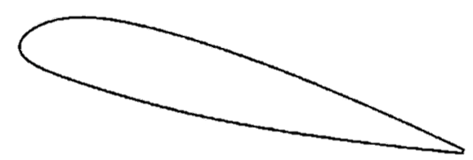
C
P
Q

$$\ddot{h}$$
$$K_{h}h$$


$$\ddot{θ}$$
Accelerations:

C
$$P$$

$${\ddot{u}}_{y}=\ddot{h}-x_{cp}\ddot{θ}$$

Equation of Motion for Plunge (Vertical Force Balance)
$$\sum{F_{y}}=m{\ddot{u}}_{y}=m\left(\ddot{h}-x_{CP}\ddot{θ}\right)$$
$$-L-K_{h}h=m\ddot{h}-mx_{CP}\ddot{θ}$$
$$m\ddot{h}-mx_{CP}\ddot{θ}+K_{h}h+L=0$$
Equation of Motion for Pitch (Moment Balance about P)
$$I_{P}=I_{0}+mx_{cp}^{2}$$
Translation of 2nd moment of inertia
$$\sum{M_{P}}=I_{o}\ddot{θ}-m{\ddot{u}}_{y}x_{CP}$$
$$Lx_{QP}-K_{θ}θ=I_{O}\ddot{θ}-m{\ddot{u}}_{y}x_{CP}$$
$$=I_{O}\ddot{θ}-m\left(\ddot{h}-x_{CP}\ddot{θ}\right)x_{cp}$$
$$=I_{O}\ddot{θ}-mx_{CP}\ddot{h}+mx_{cp}^{2}\ddot{θ}$$
$$=-mx_{CP}\ddot{h}+\left(I_{o}+mx_{cp}^{2}\right)\ddot{θ}$$
$$=-mx_{CP}\ddot{h}+I_{p}\ddot{θ}$$
$$-mx_{CP}\ddot{h}+I_{P}\ddot{θ}+K_{θ}θ-Lx_{QP}=0$$

Part b:
- Make linearity assumption on lift L and express L(U,θ)=L₀(U)θ, where U is the airspeed

Assumptions:
- Linear Dependence on angle of attack
- Symmetric airfoil (No moment at Angle of Attack equal 0)
- Ideal lift curve slope $a_{1}=2π$
- Subsonic and incompressible
- Rigid airfoil (linear analysis)
- Fully attached airflow
$$C_{L}$$
- Ignore drag effects
- Small angle approximation $\left(θ≪1 rad; \begin{matrix}sinθ≈θ \\ cosθ≈1\end{matrix}\right)$
Lift is generated by an airfoil as described by the lift equation:
$$L=\left(\frac{1}{2}ρU^{2}S\right)C_{L}$$

$Dynamic Pressure=q=\frac{1}{2}ρU^{2}$
$$a_{1}=2π$$
$$θ$$

$$C_{L}=a_{1}θ$$

Vocab | Description
$$L$$ | Lift Force
$$ρ$$ | Air Density
$$U$$ | Airspeed
$$S$$ | Wing Area
$$C_{L}$$ | Lift Coefficient

$$L\left(U\right)=L_{0}\left(u\right)θ$$
$$L=\left(\frac{1}{2}ρU^{2}S\right)a_{1}θ$$

$$L_{D}\left(U\right)=\frac{1}{2}ρU^{2}Sa_{1}$$

$L(U)$ can be plugged into EOM for Plunge and Pitch:
EOM Plunge:
$$m\ddot{h}-mx_{CP}\ddot{θ}+K_{h}h+L_{0}\left(u\right)θ=0$$

EOM Pitch:
$$-mx_{CP}\ddot{h}+I_{P}\ddot{θ}+K_{θ}θ-L_{0}\left(u\right)θx_{QP}=0$$

Part c:
- Express equations of motion in terms of the plunge and pitch frequencies ω_{h}, ω_{θ}

EOM Plunge: $m\ddot{h}-mx_{cp}\ddot{θ}+K_{h}h+L_{0}\left(u\right)θ=0$
EOM Pitch: $-mx_{cp}\ddot{h}+I_{P}\ddot{θ}+K_{θ}θ-L_{0}\left(u\right)θx_{QP}=0$

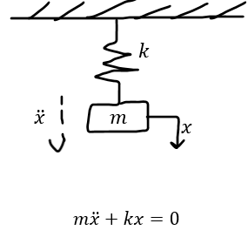
1 Degree of Freedom Vibration Analysis:
Equation of motion for a mass attached to a spring ($k)$:
$$m\ddot{x}+kx=0$$
Assumed Solution:
$$x=\hat{x}e^{st}$$
$$\hat{x}=amplitude$$
Substitute into the equation:
$$x=\hat{x}e^{st}$$
$$\ddot{x}=s^{2}x$$
$$\left(ms^{2}+k\right)\hat{x}=0$$
For a nontrivial solution $\hat{x}≠0$ so the terms inside the parentheses must equal zero:
$$\left(ms^{2}+k\right)=0→s^{2}=-\frac{k}{m}=-ω_{n}^{2}$$
So, the solution is ‘s’:

$$ω_{n}=natural freq,\frac{rad}{s}$$
$$f_{n}=\frac{ω_{n}}{2π}, Hz$$

$$s=±iω_{n}, ω_{n}=\sqrt{\frac{k}{m}}$$

So:
$$x\left(t\right)=c_{1}e^{iωt}+c_{2}e^{-iωt}=Ccos(ωt+φ)$$

Uncoupled free vibration of airfoil $(U=0, x_{CP}=0)$
Plunge:
$$m\ddot{h}+K_{h}h=0$$
$$\ddot{h}+ω_{h}^{2}h=0$$
$$ω_{h}^{2}=\frac{K_{h}}{m}$$
The plunge motion is governed by equation $m\ddot{h}+K_{h}h=0$, with a natural frequency of $ω_{h}=\sqrt{\frac{K_{h}}{m}}$

Pitch:
$$I_{0}\ddot{θ}+K_{θ}θ=0$$
$$\ddot{θ}+ω_{θ}^{2}θ=0$$
$$ω_{θ}^{2}=\frac{K_{θ}}{I_{0}}$$
The plunge motion is governed by equation $I_{0}\ddot{θ}+K_{θ}θ=0$, with a natural frequency of $ω_{θ}=\sqrt{\frac{K_{θ}}{I_{0}}}$

EOM Plunge: $m\ddot{h}-mx_{cp}\ddot{θ}+K_{h}h+L_{0}\left(u\right)θ=0$
Divide the EOM for Plunge by $m$:
$$\ddot{h}-x_{CP}\ddot{θ}+\frac{K_{h}}{m}h+\frac{L_{0}\left(u\right)}{m}θ=0$$
$$\ddot{h}-x_{CP}\ddot{θ}+ω_{h}^{2}h+\frac{L_{0}\left(u\right)}{m}θ=0$$

EOM Pitch: $-mx_{cp}\ddot{h}+I_{P}\ddot{θ}+K_{θ}θ-L_{0}\left(u\right)θx_{QP}=0$
Divide the EOM for Pitch by $I_{0}$:
$$-\frac{m}{I_{0}}x_{CP}\ddot{h}+\frac{I_{P}}{I_{0}}\ddot{θ}+\frac{K_{θ}}{I_{0}}θ-\frac{L_{0}\left(u\right)x_{QP}}{I_{0}}θ=0$$
$$-\frac{m}{I_{0}}x_{CP}\ddot{h}+\frac{I_{P}}{I_{0}}\ddot{θ}+ω_{θ}^{2}θ-\frac{L_{0}\left(u\right)x_{QP}}{I_{0}}θ=0$$

EOM Plunge in terms of $ω_{h}:$
$$s^{2}h-x_{CP}s^{2}θ+ω_{h}^{2}h+\frac{L_{0}\left(U\right)x_{QP}}{I_{0}}θ=0$$
EOM Pitch in terms of $ω_{θ}$:
$$-\frac{m}{I_{0}}x_{CP}s^{2}h+\frac{I_{P}}{I_{0}}s^{2}θ+ω_{θ}^{2}θ-\frac{L_{0}\left(U\right)x_{QP}}{I_{0}}θ=0$$

Part d:
- Assume , and cast equations of motion in matrix form as a polynomial eigenvalue problem
Now assume that $h\left(t\right)=\hat{h}e^{st}, θ\left(t\right)=\hat{θ}e^{st}$:
EOM Plunge in terms of $ω_{h}:$
$$s^{2}h-x_{cp}s^{2}θ+ω_{h}^{2}h+\frac{L_{0}\left(U\right)x_{QP}}{I_{0}}θ=0$$
EOM Pitch in terms of $ω_{θ}$:
Aerodynamic Mass Matrix is zero because of the simplified aerodynamics
Aerodynamic Stiffness Matrix
Structural Stiffness Matrix
$$-\frac{m}{I_{0}}x_{CP}s^{2}h+\frac{I_{P}}{I_{0}}s^{2}θ+ω_{θ}^{2}θ-\frac{L_{0}\left(U\right)x_{QP}}{I_{0}}θ=0$$
EOM for both Plunge and Pitch can be placed in matrix form.
Structural mass Matrix
$$s^{2}\left[\begin{matrix}1 & -x_{CP} \\ -\frac{m}{I_{0}}x_{CP} & \frac{I_{P}}{I_{0}}\end{matrix}\right]\left[\begin{matrix}\hat{h} \\ \hat{θ}\end{matrix}\right]+\left[\begin{matrix}ω_{h}^{2} & 0 \\ 0 & ω_{θ}^{2}\end{matrix}\right]\left[\begin{matrix}\hat{h} \\ \hat{θ}\end{matrix}\right]+\left[\begin{matrix}0 & \frac{L_{0}\left(U\right)}{m} \\ 0 & -\frac{L_{0}\left(U\right)x_{QP}}{I_{0}}\end{matrix}\right]\left[\begin{matrix}\hat{h} \\ \hat{θ}\end{matrix}\right]=\left[\begin{matrix}0 \\ 0\end{matrix}\right]$$
Polynomial Eigenvalue Problem: $s^{2}M_{S}x+K_{S}x+K_{A}\left(U\right)x=0$
$$M_{S}=\left[\begin{matrix}1 & -x_{CP} \\ -\frac{m}{I_{0}}x_{CP} & \frac{I_{P}}{I_{0}}\end{matrix}\right]$$
$$K_{S}=\left[\begin{matrix}ω_{h}^{2} & 0 \\ 0 & ω_{θ}^{2}\end{matrix}\right]$$
$$K_{A}\left(U\right)=\left[\begin{matrix}0 & \frac{L_{0}\left(U\right)}{m} \\ 0 & -\frac{L_{0}\left(U\right)x_{QP}}{I_{0}}\end{matrix}\right]$$
$$M_{A}=\left[\begin{matrix}0 & 0 \\ 0 & 0\end{matrix}\right]$$
Eigenvalue Problem: $\left(s^{2}M+K\left(U\right)\right)=0$
$$\begin{aligned}M=M_{S}+M_{A}\#Total system mass matrix\end{aligned}$$
$$\begin{aligned}K\left(U\right)=K_{S}+K_{A}\left(U\right)\#Total system stiffness matrix\end{aligned}$$
The eigenvalue $s$ provides info on the natural frequency and the damping of the system. If the real part of $s$ is negative than the system should return to equilibrium overtime.

Ground Vibration Test (GVT) Analysis
Consider the airfoil shown in Figure 1 but with zero airspeed U=0. This condition corresponds to ground vibration testing (GVT). Do the following:
- Display input data
- Calculate the spring stiffnesses K_{h} and K_{θ} corresponding to the uncoupled frequencies f_{h} and f_{θ}
- Let x_{CP}= –10% of c and calculate the following:
  - x_{CP} and the moment of inertia I_{P} about elastic center P
  - structural mass matrix Μ_{S} and structural stiffness matrix K_{S}
  - eigenvalues s₁, s₂, s₃, s₄ and eigenvectors V₁, V₂, V₃, V₄ (sort eigenvalues in ascending amplitude order, rearrange eigenvectors according to the eigenvalue sorting, and normalize each eigenvector wrt its largest element)
  - coupled vibration frequencies f_{I} and f_{II}, uncoupled frequencies f_{h}, f_{θ} and percentage difference
  - modeshapes V_{I}, V_{II} corresponding to the frequencies f_{I}, f_{II}.
- Lat x_{CP} = –20%, –10%, –1%, 0, 1%, 10% of c, 20% and calculate in table format the following:
- x_{CP} and the moment of inertia I_{P} about elastic center P
- eigenvalues s₁, s₂, s₃, s₄ and eigenvectors V₁, V₂, V₃, V₄ (sort eigenvalues in ascending amplitude order, rearrange eigenvectors according to the eigenvalue sorting, and normalize each eigenvector wrt its largest element)
- coupled vibration frequencies f_{I} and f_{II} and percentage difference from the uncoupled frequencies f_{h}, f_{θ}.
- modeshapes V_{I}, V_{II} corresponding to the frequencies f_{I}, f_{II}.
- Comment on your results.

Solution

Part a:
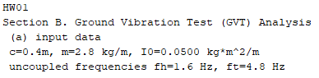

Part b:
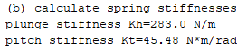

Part c:
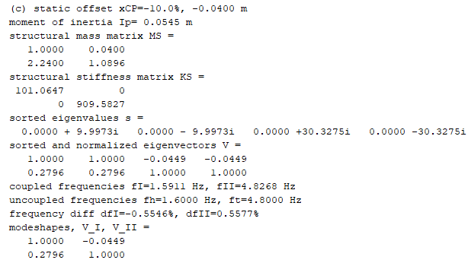

Part d:
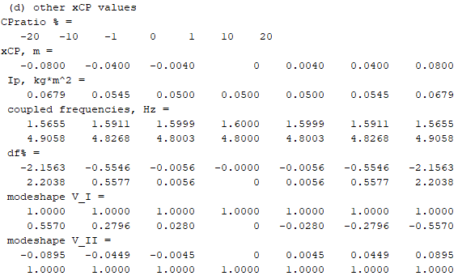

Part e:
Discussion of the results:
The GVT analysis revealed that the calculated spring stiffness for plunge and pitch were $K_{h}=283.0\frac{N}{m}$ and $K_{θ}=45.48 N*\frac{m}{rad}$, respectively, corresponding to the uncoupled frequencies $f_{h}=1.6Hz$ and $f_{θ}=4.8 Hz$. As the static offset $x_{cp}$ was varied from $-20\%$ to $20\%$ of ther chord, the moment of inertia about the elastic center $I_{P}$ ranged from $0.05 kg*m^{2}$ to $0.0679 kg*m^{2}$. The mode shapes associated with these eigenvalues indicate a smooth transition, with the coupled vibration frequencies $f_{I}=1.59 Hz$ and $f_{II}=4.83 Hz$ showing minimal deviation from their uncoupled counterparts. This suggests that the GVT system is showing stable behavior.

Flutter Analysis

Eigen analysis of flutter
Recall the aeroelastic equations of motion in matrix form expressed as a polynomial eigenvalue problem:
where , M=M_{S}+M_{A}, K(U)=K_{S}+K_{A}(U)
Give the expressions for all the matrices

Solution:
EOM for both Plunge and Pitch can be placed in matrix form.
Structural mass Matrix
$$s^{2}\left[\begin{matrix}1 & -x_{CP} \\ -\frac{m}{I_{0}}x_{CP} & \frac{I_{P}}{I_{0}}\end{matrix}\right]\left[\begin{matrix}\hat{h} \\ \hat{θ}\end{matrix}\right]+\left[\begin{matrix}ω_{h}^{2} & 0 \\ 0 & ω_{θ}^{2}\end{matrix}\right]\left[\begin{matrix}\hat{h} \\ \hat{θ}\end{matrix}\right]+\left[\begin{matrix}0 & \frac{L_{0}\left(U\right)}{m} \\ 0 & -\frac{L_{0}\left(U\right)x_{QP}}{I_{0}}\end{matrix}\right]\left[\begin{matrix}\hat{h} \\ \hat{θ}\end{matrix}\right]=\left[\begin{matrix}0 \\ 0\end{matrix}\right]$$
Polynomial Eigenvalue Problem: $s^{2}M_{S}x+K_{S}x+K_{A}\left(U\right)x=0$
Aerodynamic Mass Matrix is zero because of the simplified aerodynamics
Aerodynamic Stiffness Matrix
Structural Stiffness Matrix
$$M_{S}=\left[\begin{matrix}1 & -x_{CP} \\ -\frac{m}{I_{0}}x_{CP} & \frac{I_{P}}{I_{0}}\end{matrix}\right]$$
$$K_{S}=\left[\begin{matrix}ω_{h}^{2} & 0 \\ 0 & ω_{θ}^{2}\end{matrix}\right]$$
$$K_{A}\left(U\right)=\left[\begin{matrix}0 & \frac{L_{0}\left(U\right)}{m} \\ 0 & -\frac{L_{0}\left(U\right)x_{QP}}{I_{0}}\end{matrix}\right]$$
$$M_{A}=\left[\begin{matrix}0 & 0 \\ 0 & 0\end{matrix}\right]$$

$$M=M_{S}+M_{A}=\left[\begin{matrix}1 & -x_{CP} \\ -\frac{m}{I_{0}}x_{CP} & \frac{I_{P}}{I_{0}}\end{matrix}\right]$$
$$K\left(U\right)=K_{S}+K_{A}\left(U\right)=\left[\begin{matrix}ω_{h}^{2} & 0 \\ 0 & ω_{θ}^{2}\end{matrix}\right]\left[\begin{matrix}0 & \frac{L_{0}\left(U\right)}{m} \\ 0 & -\frac{L_{0}\left(U\right)x_{QP}}{I_{0}}\end{matrix}\right]=\left[\begin{matrix}ω_{h}^{2} & \frac{L_{0}\left(U\right)}{m} \\ 0 & ω_{θ}^{2}-\frac{L_{0}\left(U\right)x_{QP}}{I_{0}}\end{matrix}\right]$$

Flutter diagram
Let x_{CP}= –10% of c, x_{QP}= 30% of c. Let U=0,…,12 m/s with 1001 steps.
  - Display input data
  - Plot frequencies and damping vs. airspeed. Use these plots to find the flutter speed U_{F} and insert datatips appropriately.
  - State the value of U_{F} in m/s and knots.

Solution:

Part a:
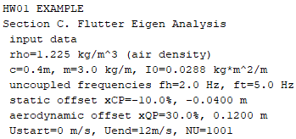

Part b:
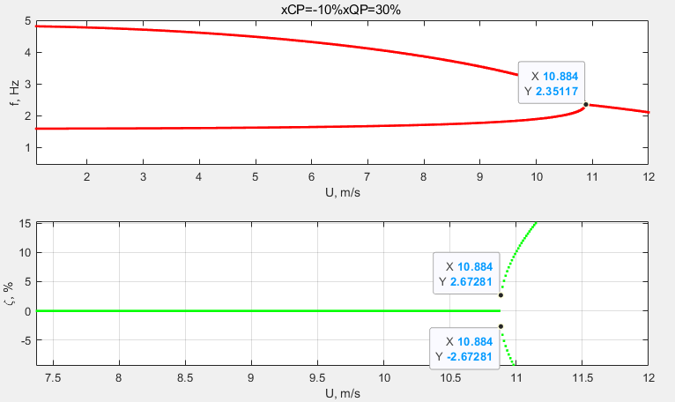

Part c:
$$U_{F}≈10.884 m/s$$
$$1knot=0.51444 m/s$$
$$U_{F}≈10.884\left(\frac{m}{s}\right)*\frac{1knot}{0.51444\left(\frac{m}{s}\right)}=21.15698 knots$$

Frequencies and modeshapes near flutter speed
Let U= 0, 6m/s, (1–ε)U_{F}, U_{F}, (1+ε)U_{F}, with ε=1%
- find frequencies and modeshapes at each of these speeds
- discuss your results

Part a:
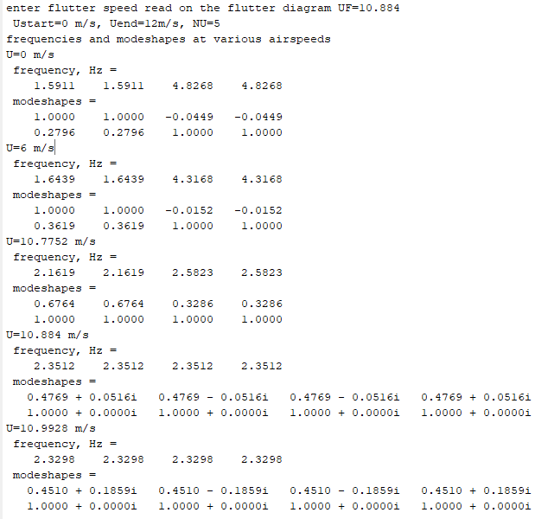

Part b:
Discussion of the results:
The mode shapes of the first three flutter speeds all consist of real numbers, whereas the last two flutter speeds $U=10.884 m/s$ and $U=10.9928 m/s$ both show that the airspeed has approached its critical value as can be seen by the imaginary numbers for the mode shapes for these two flutter speeds.

Static offset effect on flutter speed
Let U=9,…,15 m/s with 1001 steps. Keep x_{QP}= 30% of c.
Let x_{CP} = –20%, –15%, –10%, –5%, –1%, –0.1% of c. Do the following:
- Display input data
- Plot overlapped (hold on) frequencies and damping vs. airspeed for each value of x_{CP}. Insert datatips to locate the flutter speed U_{F}. Present the U_{F} results in table format.
- Plot the variation of flutter speed U_{F} with x_{CP}%. Make sure the plot covers the whole U range.
- Discuss how x_{CP} influences the flutter speed.
- Repeat for x_{CP} = 0, 0.1%, 0.5%, 10%, 15%, 20% of c.

Solution

Part a:
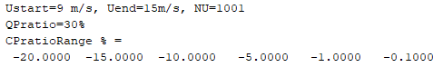

Part b:
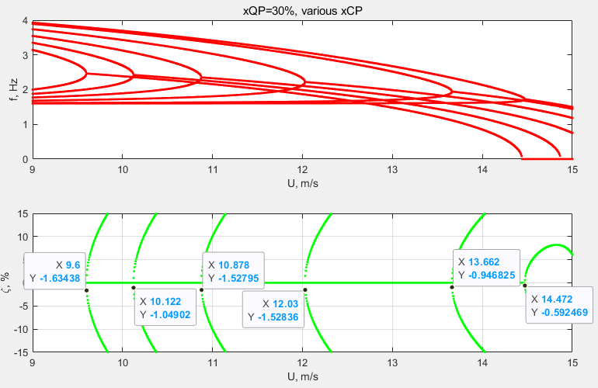

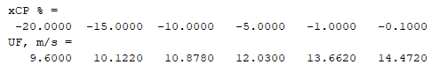

Part c:
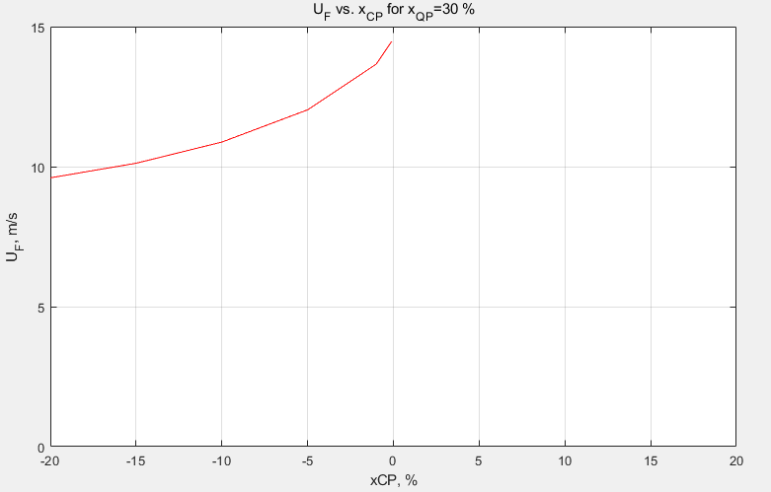

Part d:
Discussion of the results:
The static offset effect on flutter speed analysis showed that as $x_{cp}$ increased from $-20\%$ to $-0.1\%$ of the chord, the flutter speed increased from $9.6 m/s$ to $14.47 m/s$. This increase indicates that moving the center of mass closer to the aerodynamic center improves the stability of the system by increasing the flutter speed.

Part e:
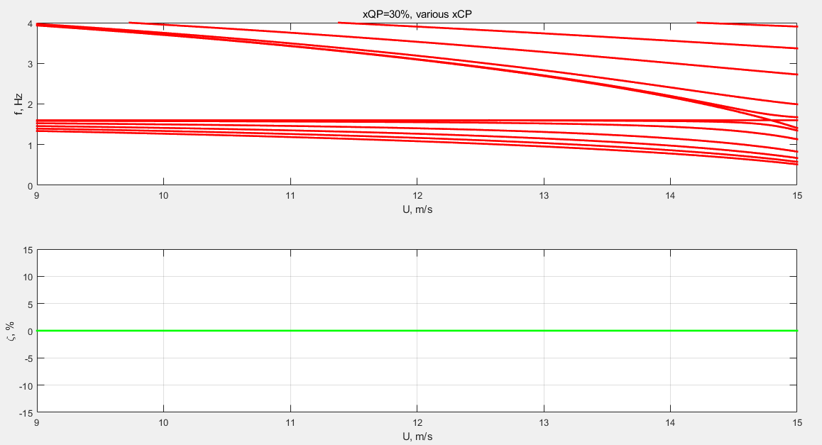
There is no flutter for values greater than $x_{cp}≥0$

Aerodynamic offset effect on flutter speed
Let U=10,…,13 m/s with 1001 steps. Keep x_{CP}= –10% of c.
Let x_{QP} = 20%, 25%, 30% of c. Do the following:
- Display input data
- Plot overlapped (hold on) frequencies and damping vs. airspeed for each value of x_{CP}. Insert datatips to locate the flutter speed U_{F}. Present the U_{F} results in table form.
- Plot the variation of flutter speed U_{F} with x_{QP}%. Make sure the plot covers the whole U range.
- Discuss how x_{QP} influences the flutter speed.

Solution:

Part a:
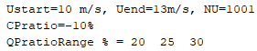

Part b:
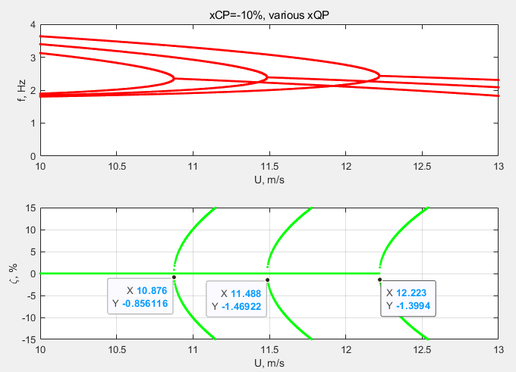

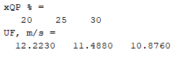

Part c:
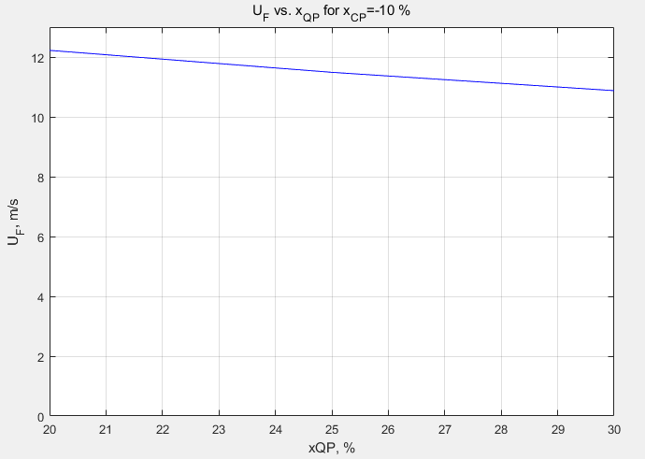

Part d:
Discussion of the results:
As $x_{QP}$ increased from 20% to 30% of the chord, the flutter speed decreased from 12.2 m/s to 10.88 m/s respectively. The graph in part c shows a linear relationship where $x_{QP}$ is inversely proportional to $U_{F}.$ So increases in $x_{QP}$ for this airfoil indicate that the airfoil will become more susceptible to flutter, increasing the risk of dangerous oscillations.

Divergence speed

- Let x_{CP}= –10% of c, x_{QP}= 30% of c. Let U=0,…, 20 m/s with 1001 steps.
- Display input data
- Plot extended flutter diagram
- Identify with a datatip the location of U_{D} on the extended flutter diagram
- Let x_{QP} = 20%, 25%, 30% of c. Calculate and plot divergence speed U_{D} vs. x_{QP}%. Make sure the plot covers the whole range of U_{D}.
- Discuss the comparison between the results of items (a) and (b)

Solution:

Part a:
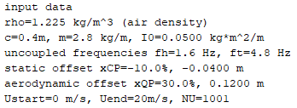
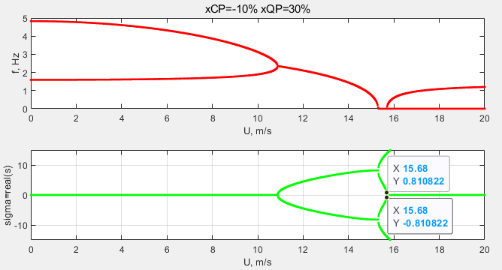

Part b:
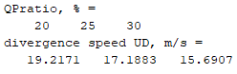
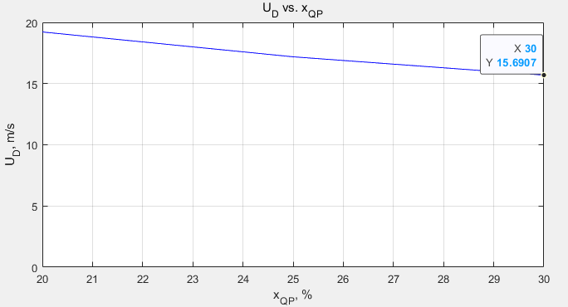

Part c:
Discussion of the results:
The comparison between parts (a) and (b) show that as the aerodynamic offset $x_{QP}$ increases, the divergence speed $U_{D}$ decreases. Both the extended flutter diagram and the linear trend the $U_{D}$ vs $x_{QP}$ plot consistently show this relationship.

Damped GVT and Flutter

Analysis of damped GVT and flutter
- Recall from class the damped flutter equations of motion in terms of the plunge and pitch frequencies f_{h}, f_{θ}, damping ζ_{h}, ζ_{θ}, inertias m, I₀, I_{P}, and lift function L₀(U). Clearly state your assumptions.
- Assume , and cast the equations of motion in matrix form as an polynomial eigenvalue problem
where , M=M_{S}+M_{A}, C=C_{S}+C_{A}, K(U)=K_{S}+K_{A}(U)
Give the expressions for all the matrices.

Solution:

Part a:
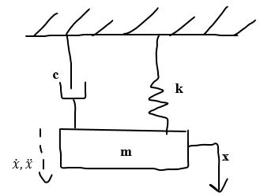
Damped 1-DOF Vibration
Assumptions:
- Linear Dependence on angle of attack
- Symmetric airfoil (No moment at Angle of Attack equal 0)
- Ideal lift curve slope $a_{1}=2π$
- Subsonic and incompressible
- Rigid airfoil (linear analysis)
- Fully attached airflow
- Ignore drag effects
- Small angle approximation $\left(θ≪1 rad; \begin{matrix}sinθ≈θ \\ cosθ≈1\end{matrix}\right)$
$$m\ddot{x}+c\dot{x}+kx=0$$
Where:
- $m$ is mass
- $c$ is the damping coefficient
- $k$ is the stiffness
- $x$ is the displacement
Assumed solution: $x(t)=\hat{x}e^{st}$
$$x=\hat{x}e^{st}$$
$$\dot{x}=s\hat{x}e^{st}$$
$$\ddot{x}=s^{2}\hat{x}e^{st}$$
Plugging in the solution:
$$ms^{2}\hat{x}e^{st}+cs\hat{x}e^{st}+k\hat{x}e^{st}=0$$
$$ms^{2}\hat{x}+cs\hat{x}+k\hat{x}=0$$
$$\left(ms^{2}+cs+k\right)x=0$$
For a nontrivial solution $x≠0$
$$ms^{2}+cs+k=0$$
$$s_{1,2}=\frac{-c±\sqrt{c^{2}-4mk}}{2m}=-\frac{c}{2m}±i\sqrt{\frac{k}{m}-{\left(\frac{c}{2m}\right)}^{2}}$$
The critical damping is defined as $c_{cr}=2\sqrt{mk}$
Damping ratio: $ζ=\frac{c}{c_{cr}}=\frac{c}{2\sqrt{mk}}=\frac{c}{2m}\frac{1}{\sqrt{\frac{k}{m}}}$
$$\frac{c}{2m}=ζω_{n}$$
$$s_{1,2 }=-ζω_{n}±i\sqrt{ω_{n}^{2}-ζ^{2}ω_{n}^{2}}=-ζω_{n}±iω_{n}\sqrt{1-ζ^{2} }$$
$$s_{1,2 }=-ζω_{n}±iω_{d}$$
Solution to the Differential Equation:
$$x\left(t\right)=c_{1}e^{s_{1}t}+c_{2}e^{s_{2}t}$$Substitute $s_{1}, s_{2}$ into $x(t)$:
$$x(t)=e^{-ζω_{n}t}\left(c_{1}e^{iω_{d}t}+c_{2}e^{-iω_{d}t}\right)$$
Written using the Euler’s Formula:
$$x(t)=Ce^{-ζω_{n}t}cos⁡(ω_{d}t+φ)$$

Equation of Motion for Plunge with Damping
$$m\ddot{h}-mx_{CP}\ddot{θ}+c_{h}\dot{h}+K_{h}h+L=0$$
Equation of Motion for Pitch with Damping
$$-mx_{CP}\ddot{h}+I_{P}\ddot{θ}+c_{θ}\dot{θ}+K_{θ}θ-Lx_{QP}=0$$

Part b:
Assume , and cast the equations of motion in matrix form as an polynomial eigenvalue problem where , M=M_{S}+M_{A}, C=C_{S}+C_{A}, K(U)=K_{S}+K_{A}(U)
Give the expressions for all the matrices.

Assumption: It has a harmonic solution
$$h(t)=\hat{h}e^{st}$$
$$\dot{h}(t)=s\hat{h}e^{st}$$
$$\ddot{h}(t)=s^{2}\hat{h}e^{st}$$
$$θ\left(t\right)=\hat{θ}e^{st}$$
$$\dot{θ}\left(t\right)=s\hat{θ}e^{st}$$
$$\ddot{θ}\left(t\right)=s^{2}\hat{θ}e^{st}$$
Substitute the harmonic solution into the EOM’s

Equation of Motion for Plunge with Damping
$$m\left(s^{2}\hat{h}e^{st}\right)-mx_{CP}\left(s^{2}\hat{θ}e^{st}\right)+c_{h}\left(s\hat{h}e^{st}\right)+K_{h}\left(\hat{h}e^{st}\right)+L=0$$
$L$ represents an aerodynamic force and is a function of airspeed and not time-dependent, so the term $e^{st}$ doesn’t apply to the external forces like $L$ unless problem statement states $L$ varies with time
$$ms^{2}\hat{h}-mx_{CP}s^{2}\hat{θ}+c_{h}s\hat{h}+K_{h}\hat{h}+L=0$$

Equation of Motion for Pitch with Damping
$$-mx_{CP}s^{2}\hat{h}+I_{P}s^{2}\hat{θ}+c_{θ}s\hat{θ}+K_{θ}\hat{θ}-Lx_{QP}=0$$
Matrix Form:
$$\left[\begin{matrix}ms^{2}+c_{h}s+K_{h} & -mx_{CP}s^{2} \\ -mx_{CP}s^{2} & I_{P}s^{2}+c_{θ}s+K_{θ}\end{matrix}\right]\left[\begin{matrix}\hat{h} \\ \hat{θ}\end{matrix}\right]=\left[\begin{matrix}-L \\ Lx_{QP}\end{matrix}\right]$$
Here is the matrix form of the equations of motion for plunge and pitch of the airfoil with damping and stiffness
$$M=\left[\begin{matrix}m & -mx_{CP} \\ -mx_{CP} & I_{P}\end{matrix}\right]$$
$$C=\left[\begin{matrix}c_{h} & 0 \\ 0 & c_{θ}\end{matrix}\right]$$
$$K_{S}=\left[\begin{matrix}K_{h} & 0 \\ 0 & K_{θ}\end{matrix}\right]$$
$$K_{A}\left(U\right)=\left[\begin{matrix}0 & \frac{L_{0}\left(U\right)}{m} \\ 0 & -\frac{L_{0}\left(U\right)x_{QP}}{I_{P}}\end{matrix}\right]$$
$$K\left(U\right)=K_{S}+K_{A}=\left[\begin{matrix}K_{h} & \frac{L_{0}\left(U\right)}{m} \\ 0 & K_{θ}-\frac{L_{0}\left(U\right)x_{QP}}{I_{P}}\end{matrix}\right]$$
Polynomial Eigenvalue Problem
$$\left(s^{2}\left[\begin{matrix}m & -mx_{CP} \\ -mx_{CP} & I_{P}\end{matrix}\right]+s\left[\begin{matrix}c_{h} & 0 \\ 0 & c_{θ}\end{matrix}\right]+\left[\begin{matrix}K_{h} & \frac{L_{0}\left(U\right)}{m} \\ 0 & K_{θ}-\frac{L_{0}\left(U\right)x_{QP}}{I_{P}}\end{matrix}\right]\right)\left[\begin{matrix}\hat{h} \\ \hat{θ}\end{matrix}\right]=\left[\begin{matrix}0 \\ 0\end{matrix}\right]$$

Setup for damped GVT and flutter Calculations
Augment input data with the following modal damping values:
- Plunge damping ratio: ζ_{h}=2%
- Pitch damping ratio: ζ_{θ}=3%

Display updated input data

Solution:
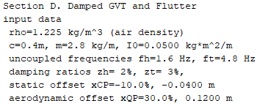

Damped GVT analysis
Let U=0 and study the effect of damping on GVT:
  - Calculate damped frequencies and compare them with the undamped frequencies
  - Calculate modal damping and compare with the uncoupled modal damping
  - Calculate damped modeshapes and compare them with the undamped modeshapes
  - Results Discussion

Solution:

Part a:
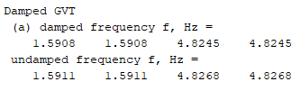

Part b:
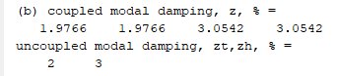

Part c:
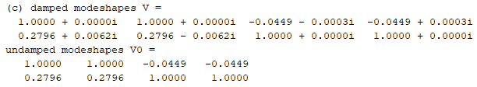

Part d:
Discussion of the results:
The introduction of damping into the GVT analysis had a noticeable effect on the system’s response. The damped frequencies were ever so slightly less than that of the undamped frequencies. Something notable is that the damped mode shapes include both real and imaginary numbers whereas the undamped are only real number mode shapes.

Damped flutter analysis
Let U=0…14 m/s with 1001 steps and study the effect of damping on flutter speed U_{F}
- Plot frequencies and damping vs. airspeed; find the damped flutter speed U_{F} on these plots.
- State the value of U_{F} in m/s and knots
- Plot the undamped diagram on top of the damped diagram and identify the undamped flutter speed and the damped flutter speed U_{F}.
- Discuss the difference between the damped and undamped flutter speeds

Solution:

Part a:
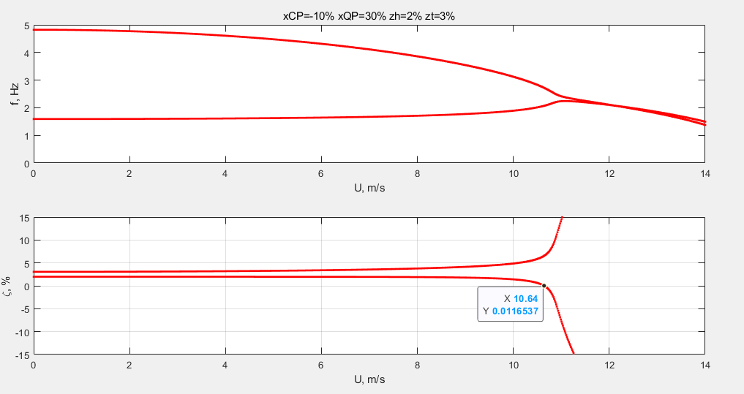

Part b:
$$U_{F}=10.64\left(\frac{m}{s}\right)=20.69 knots$$
$$U_{F}=10.64\left(\frac{m}{s}\right)*\frac{1.94384knots}{1\left(\frac{m}{s}\right)}=20.68 knots$$

Part c:
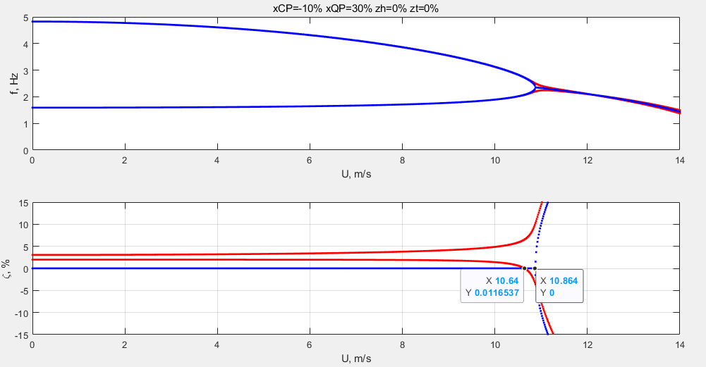
$$U_{F}=10.64\left(\frac{m}{s}\right)$$
$$U_{F}^{undamped}=10.864\left(\frac{m}{s}\right)$$

Part d:
Discussion of the results:
The damped flutter analysis shows that the flutter speed $U_{F}$ with damping is slightly lower than that of the undamped. Specifically, it was found that the damped flutter speed was $U_{F}^{damped}=10.64 m/s$ and the undamped is $U_{F}^{undamped}=10.864 m/s$.

Extra Credit Challenge Problems
Challenge problems are optional.

GVT modeling
Consider the airfoil shown in Figure 1 but with zero airspeed U=0. This condition corresponds to ground vibration testing (GVT). Do the following:


- Deduce equations of motion. Clearly state your assumptions.
- Assume , and cast equations of motion in matrix form as a polynomial eigenvalue problem where

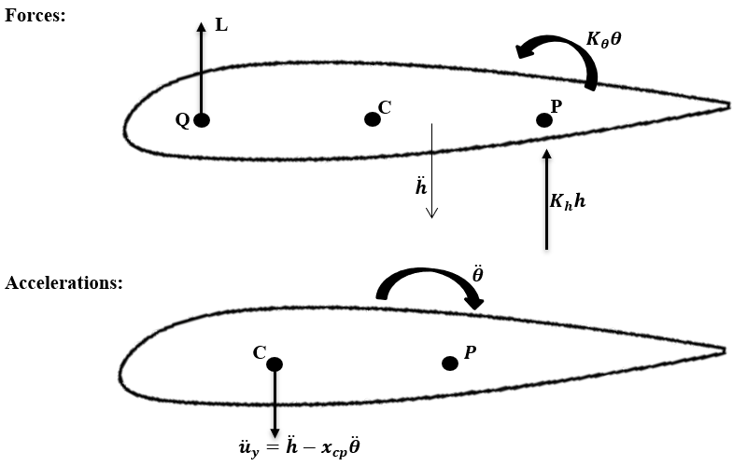
Solution:

Part a:
At airspeed equal zero than lift is also zero
Equation of Motion for Plunge (Vertical Force Balance)
$$\sum{F_{y}}=m{\ddot{u}}_{y}=m\left(\ddot{h}-x_{CP}\ddot{θ}\right)$$
$$-L-K_{h}h=m\ddot{h}-mx_{CP}\ddot{θ}$$
$$m\ddot{h}-mx_{CP}\ddot{θ}+K_{h}h=0$$
Equation of Motion for Pitch (Moment Balance about P)
$$I_{P}=I_{0}+mx_{cp}^{2}$$
Translation of 2nd moment of inertia
$$\sum{M_{P}}=I_{o}\ddot{θ}-m{\ddot{u}}_{y}x_{CP}$$
$$Lx_{QP}-K_{θ}θ=I_{O}\ddot{θ}-m{\ddot{u}}_{y}x_{CP}$$
$$=I_{O}\ddot{θ}-m\left(\ddot{h}-x_{CP}\ddot{θ}\right)x_{cp}$$
$$=I_{O}\ddot{θ}-mx_{CP}\ddot{h}+mx_{cp}^{2}\ddot{θ}$$
$$=-mx_{CP}\ddot{h}+\left(I_{o}+mx_{cp}^{2}\right)\ddot{θ}$$
$$=-mx_{CP}\ddot{h}+I_{p}\ddot{θ}$$
$$-mx_{CP}\ddot{h}+I_{P}\ddot{θ}+K_{θ}θ=0$$

Part b:
Assumption: It has a harmonic solution
$$h(t)=\hat{h}e^{st}$$
$$\dot{h}(t)=s\hat{h}e^{st}$$
$$\ddot{h}(t)=s^{2}\hat{h}e^{st}$$
$$θ\left(t\right)=\hat{θ}e^{st}$$
$$\dot{θ}\left(t\right)=s\hat{θ}e^{st}$$
$$\ddot{θ}\left(t\right)=s^{2}\hat{θ}e^{st}$$
$$ω_{h}^{2}=\frac{K_{h}}{m} ω_{θ}^{2}=\frac{K_{θ}}{I_{0}}$$

EOM Plunge in terms of $ω_{h}:$
$$m\ddot{h}-mx_{CP}\ddot{θ}+K_{h}h=0$$
$$ms^{2}\hat{h}e^{st}-mx_{CP}s^{2}\hat{θ}e^{st}+K_{h}\hat{h}e^{st}=0$$
$$ms^{2}\hat{h}-mx_{CP}s^{2}\hat{θ}+K_{h}\hat{h}=0$$
$$s^{2}\hat{h}-x_{CP}s^{2}\hat{θ}+\frac{K_{h}}{m}\hat{h}=0$$
$$\begin{aligned}s^{2}\hat{h}-x_{CP}s^{2}\hat{θ}+ω_{h}^{2}\hat{h}=0\#EOM of Plunge\end{aligned}$$
EOM Pitch in terms of $ω_{θ}:$
$$-mx_{CP}\ddot{h}+I_{P}\ddot{θ}+K_{θ}θ-L_{0}\left(u\right)θx_{QP}=0$$
$$-mx_{CP}s^{2}\hat{h}e^{st}+I_{P}s^{2}\hat{θ}e^{st}+K_{θ}\hat{θ}e^{st}=0$$
$$-mx_{CP}s^{2}\hat{h}+I_{P}s^{2}\hat{θ}+K_{θ}\hat{θ}=0$$
$$-\frac{m}{I_{O}}x_{CP}s^{2}\hat{h}+\frac{I_{P}}{I_{0}}s^{2}\hat{θ}+\frac{K_{θ}}{I_{0}}\hat{θ}=0$$
$$\begin{aligned}-\frac{m}{I_{O}}x_{CP}s^{2}\hat{h}+\frac{I_{P}}{I_{0}}s^{2}\hat{θ}+ω_{θ}^{2}\hat{θ}=0\#EOM of Pitch\end{aligned}$$
EOM for Plunge and Pitch can be placed in matrix form:
$$s^{2}\left[\begin{matrix}1 & -x_{CP} \\ -\frac{m}{I_{0}}x_{CP} & \frac{I_{P}}{I_{0}}\end{matrix}\right]\left[\begin{matrix}\hat{h} \\ \hat{θ}\end{matrix}\right]+\left[\begin{matrix}ω_{h}^{2} & 0 \\ 0 & ω_{θ}^{2}\end{matrix}\right]\left[\begin{matrix}\hat{h} \\ \hat{θ}\end{matrix}\right]+\left[\begin{matrix}0 & 0 \\ 0 & 0\end{matrix}\right]\left[\begin{matrix}\hat{h} \\ \hat{θ}\end{matrix}\right]=\left[\begin{matrix}0 \\ 0\end{matrix}\right]$$
Polynomial Eigenvalue Problem: $s^{2}M_{S}x+K_{S}x+K_{A}\left(U\right)x=0$
$M_{S}=\left[\begin{matrix}1 & -x_{CP} \\ -\frac{m}{I_{0}}x_{CP} & \frac{I_{P}}{I_{0}}\end{matrix}\right]$ Structural Mass Matrix
$K_{S}=\left[\begin{matrix}ω_{h}^{2} & 0 \\ 0 & ω_{θ}^{2}\end{matrix}\right]$ Structural Stiffness Matrix
$K_{A}\left(U\right)=\left[\begin{matrix}0 & 0 \\ 0 & 0\end{matrix}\right]$ Aerodynamic Stiffness Matrix
$M_{A}=\left[\begin{matrix}0 & 0 \\ 0 & 0\end{matrix}\right]$ Aerodynamic Mass Matrix is zero because of simplified aerodynamics

Divergence speed modeling
Derive the expression of the divergence speed U_{D}

Solution:
$$ω_{h}^{2}h+\frac{L_{0}\left(U\right)}{m}θ=ω_{h}^{2}f_{h}(t)$$
$$θ\left(t\right)=\frac{f_{θ}\left(t\right)}{\left(1-\frac{L_{0}\left(U\right)x_{QP}}{I_{0}ω_{θ}^{2}}\right)}=\frac{f_{θ}\left(t\right)}{D(U)}$$
$$D\left(U\right)=1-\frac{L_{0}\left(U\right)x_{QP}}{I_{0}ω_{θ}^{2}}$$
$$D\left(U_{D}\right)=1-\frac{L_{0}\left(U_{D}\right)x_{QP}}{I_{0}ω_{θ}^{2}}$$
$$L_{0}\left(U_{D}\right)=\frac{1}{2}ρU_{D}^{2}ca_{1}$$
$$I_{O}ω_{θ}^{2}=x_{QP}a_{1}\left(\frac{1}{2} ρU_{D}^{2}c\right)$$
$$U_{D}=ω_{θ}\sqrt{\frac{2I_{0}}{x_{QP}a_{1}ρc}}$$

